# **Creating Stream Analytics Job Using Azure Portal**

This demo is for creating a stream analytics job through azure portal. A sample sensor data will be fed as input to the stream analytics job and data is segregated from that as output based on a query.

**Creating Azure Storage Account for Sample Sensor Data:**

Go to **+ Create New resource** and choose **Storage->Storage Account.** Give an unique name, and choose the same location that is given in the image below. Choose a resource group and click on create.

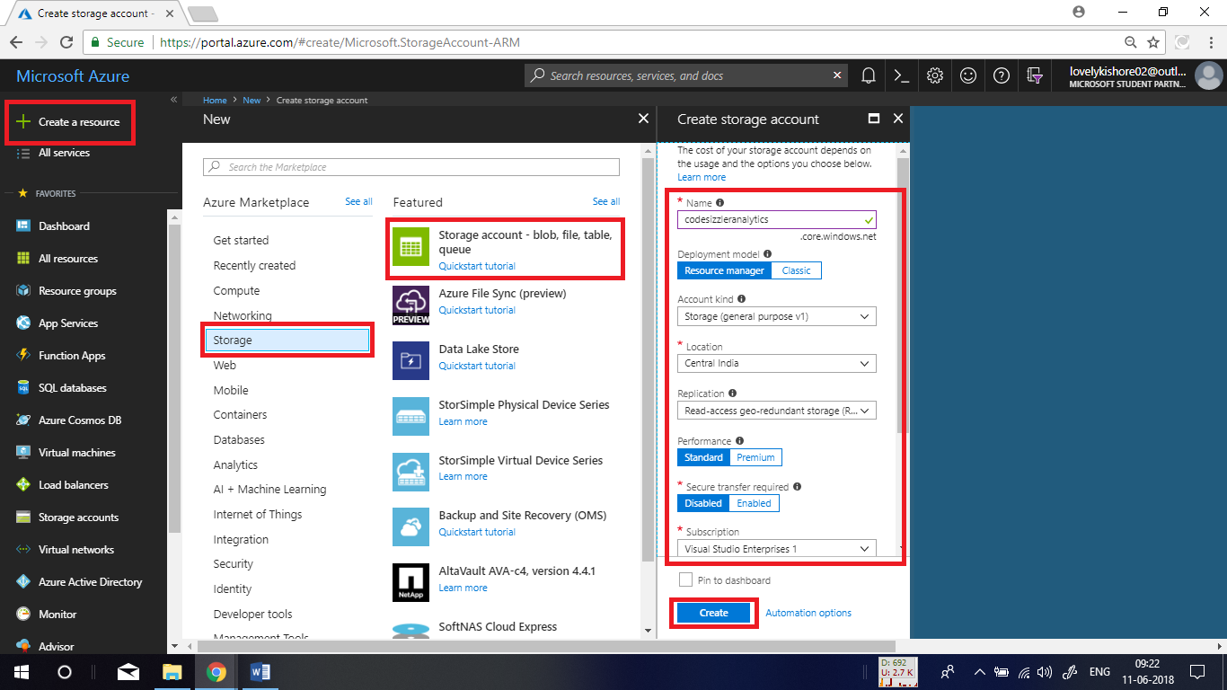

**Creating a Container:**

Now, create a container to upload sample sensor data. To do this, go to overview page of the storage account that you created and click on **Blobs.**

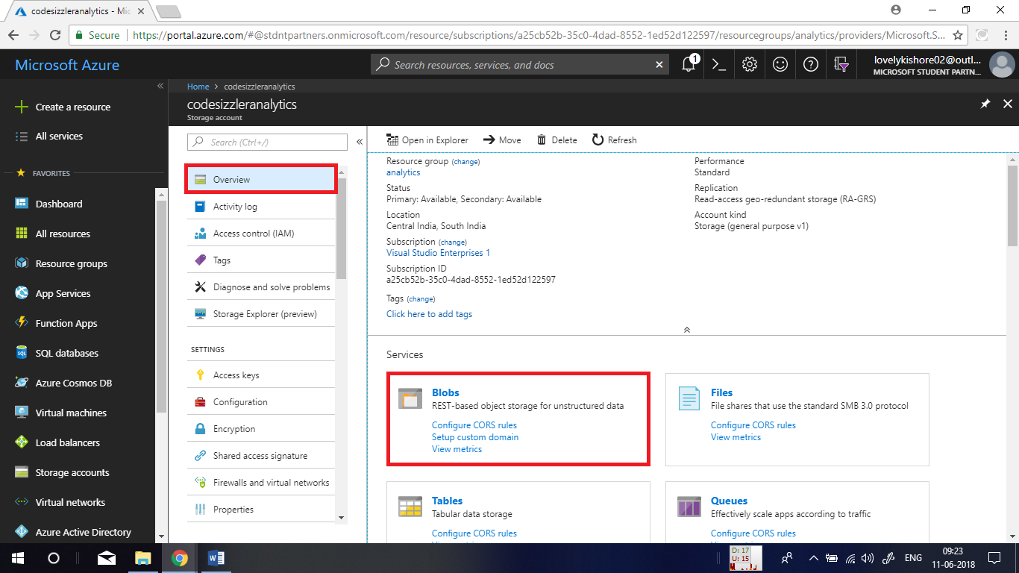

Then click on **+Container** and give a name for the container and click on ok.

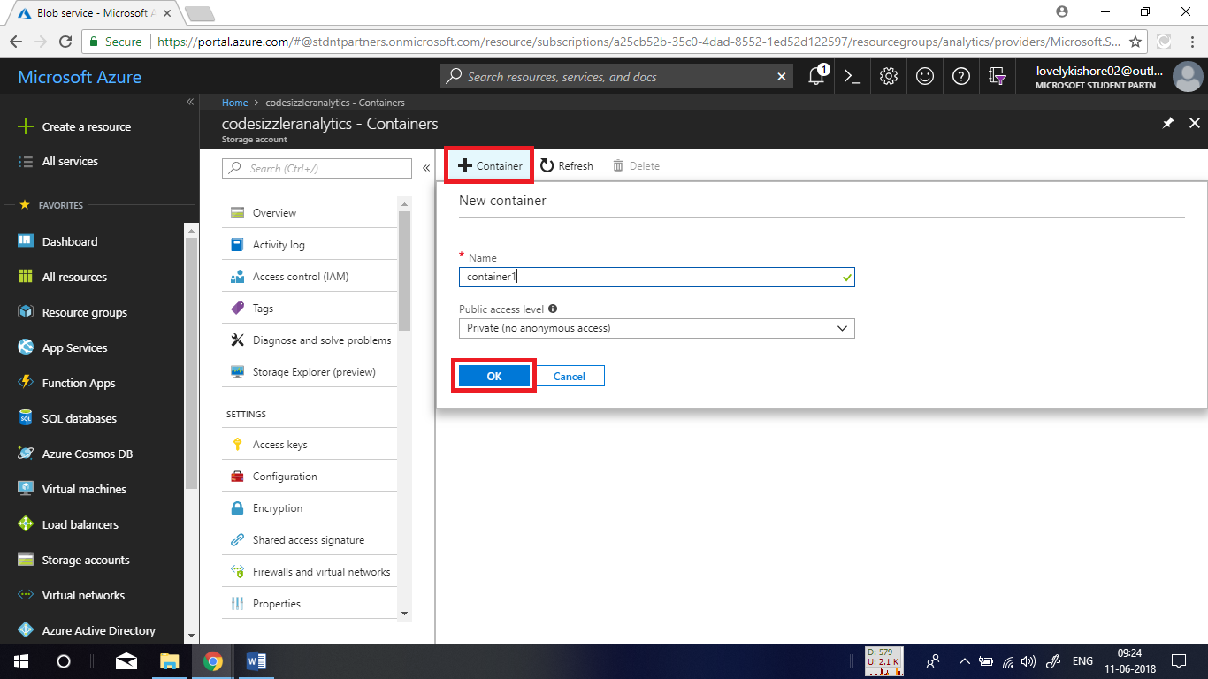

After creating the container, click and open its overview page. Let us upload some sample sensor data for streaming. Find the sample data in the following GitHub link -

<https://raw.githubusercontent.com/Azure/azure-stream-analytics/master/Samples/GettingStarted/HelloWorldASA-InputStream.json>

Save the sample data available in there in your machine in JSON format. Then click on the **Upload** at the top and choose the sample sensor data file the you saved in JSON format and click **Upload.**

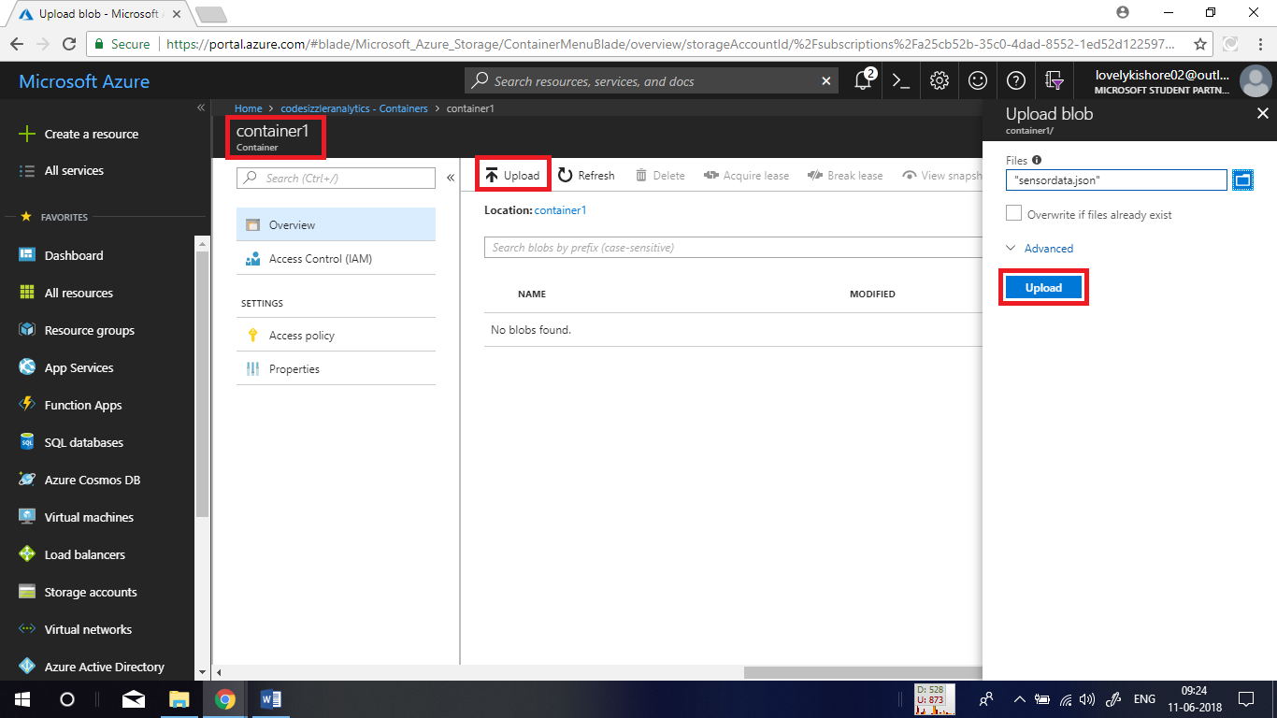

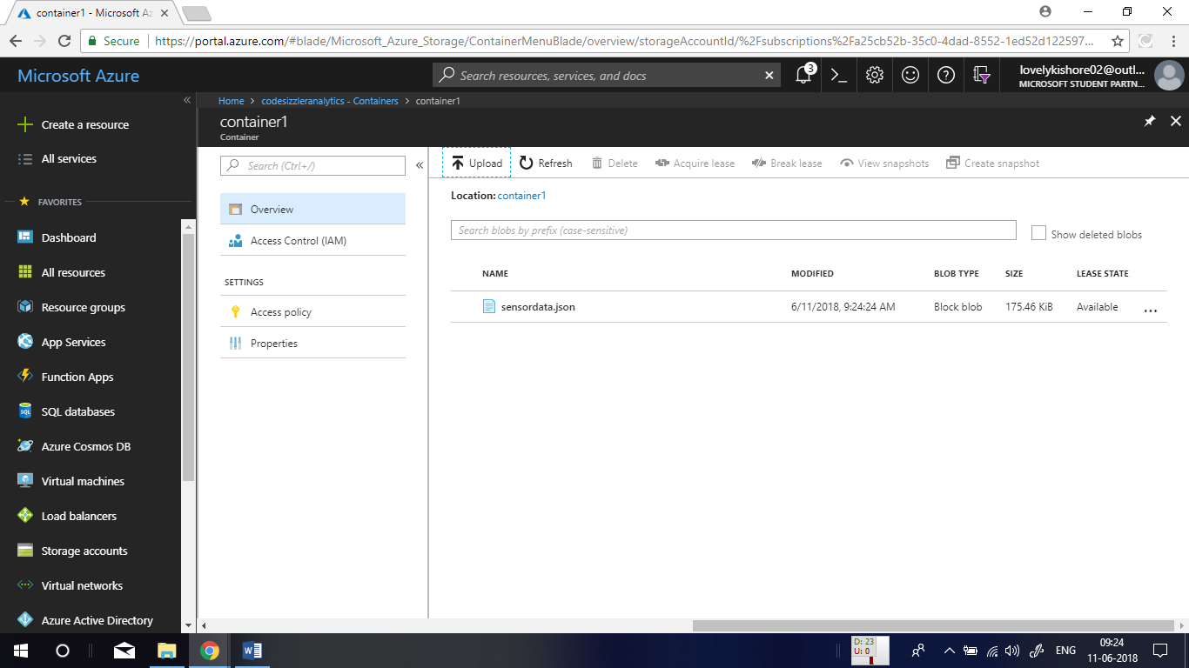

**Creating Stream Analytics Job:**

Go to **+ Create a resource -> Analytics -> Stream Analytics job**. Give the job a name, choose a resource group, a location and click on **Create** button.

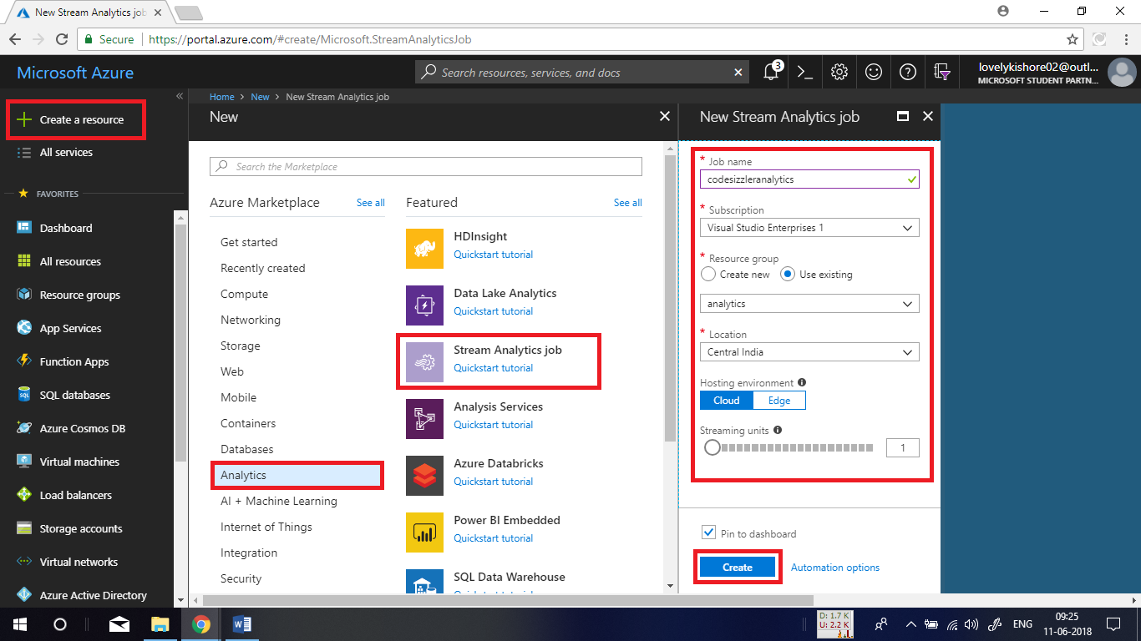

**Adding Inputs to Job:**

Once after the stream analytics job gets created, go to the **Inputs** and click on **+ Add stream input** and choose **Blob Storage**.

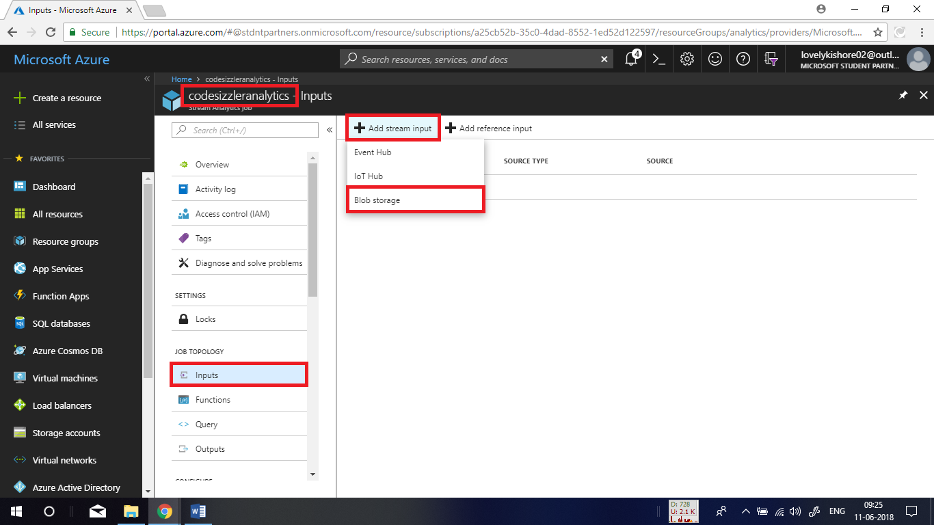

Now, give Input alias as **inputdata** and chose azure subscription. In the place of storage account choose the storage account in which you have uploaded the sample sensor data. Then chose the container in which the data is there. Finally click on **Save**.

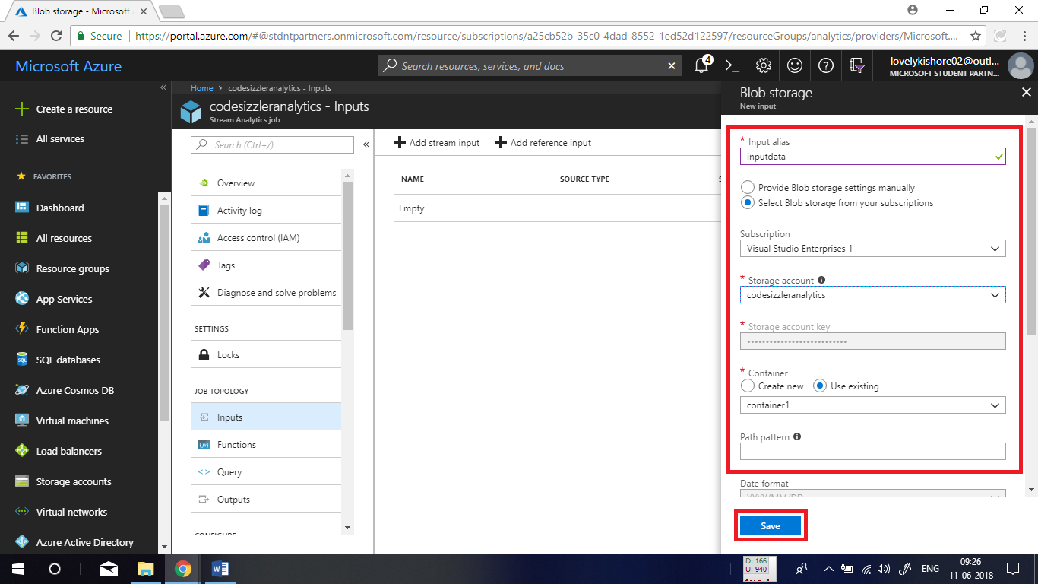

**Adding Output:**

Again, in the left side menu, click on **Outputs** and click on **+ Add** and choose **Blob Storage**.

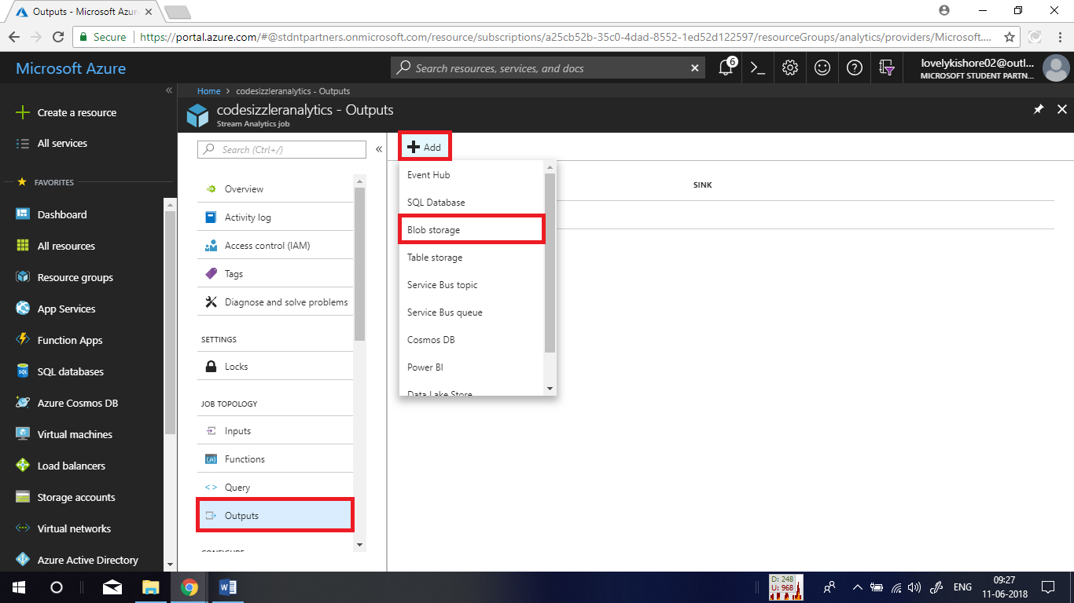

Next, name it as **outputdata** and choose the subscription and storage account in which you like to have the output of the streaming job. Choose the container for output in the **Path Pattern** give a string as **output** and click on **Save**.

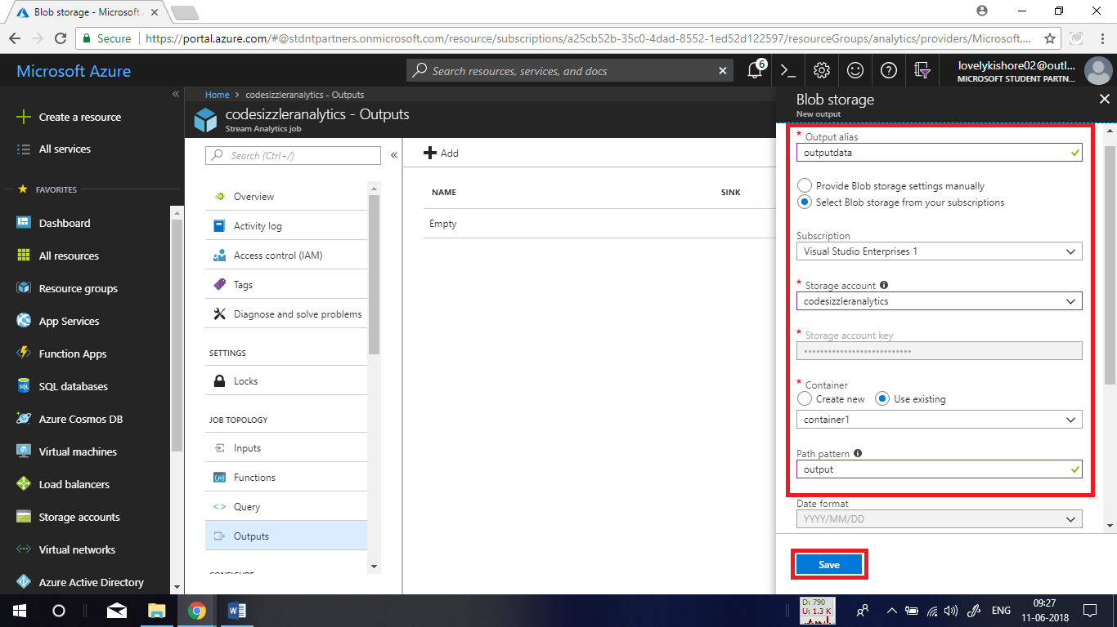

**Adding Query:**

Now, let us go to **Query** at the left side menu and add a piece of query for segregating sensor data based on temperature data. Copy the below given query and paste it in the querying pane and click on **Save.**

**Query:**

SELECT

System.Timestamp AS OutputTime,

dspl AS SensorName,

Avg(temp) AS AvgTemperature

INTO

BlobOutput

FROM

BlobInput TIMESTAMP BY time

GROUP BY TumblingWindow(second,30),dspl

HAVING Avg(temp)>100

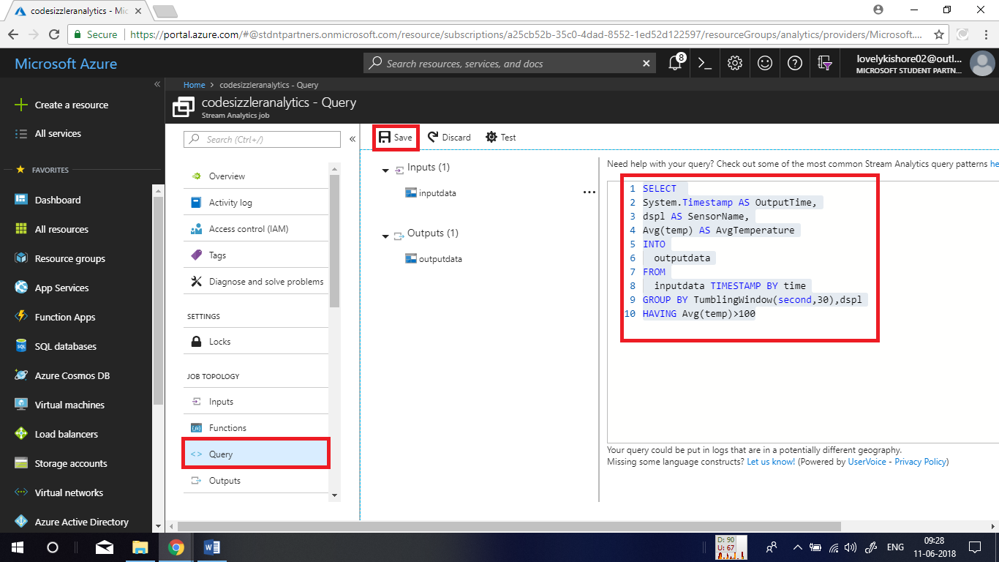

After saving the query, go to overview page of the stream analytics job and click on **Start** button. Then choose **Custom** and give date as **28-01-24** and leave the time as it is. The reason to give this date is because the sample data is streamed in the same date. Now, click on start.

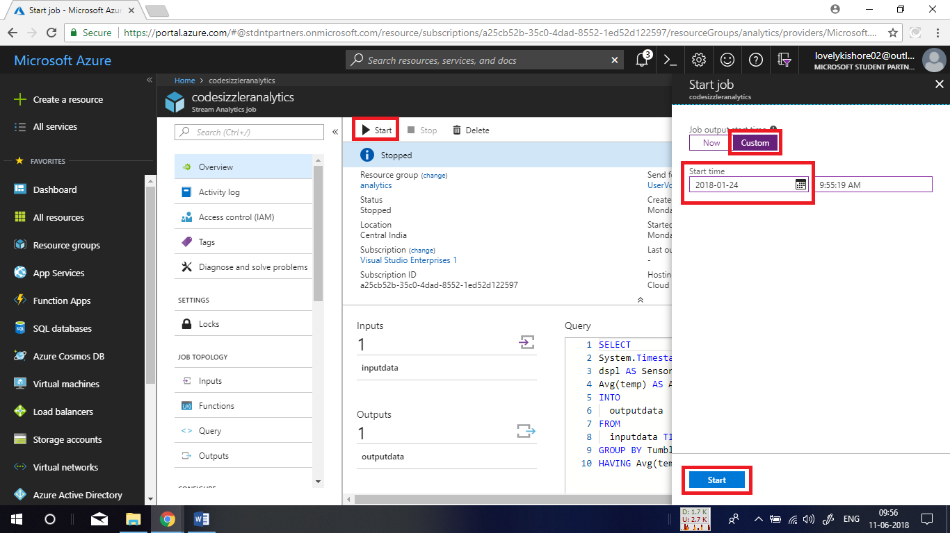

The job will take some time to start. After the job starts, go to the storage account and the container that you chose as output. In there you will be able to find a new file in which data based on the executed query can be found.

